**Table of Contents**

1 Objectives

2 Semester Plan.

3 Team Member

4 Current Phase of Project and Location on Overall Project Timeline.

5 Semester Timeline.

6 Task Description.

6 Contact

**Project Objectives**

Why are you doing the project?

* The purpose of this project is to create a device that can map out it environment and be able to navigate its way through the environment.

What specific problem are you addressing?

* The problem we are addressing is that there are some places that a human cannot go and gather information that a human cannot.

What is the mission of your team?

* The mission of the team is to create a device that will be able to map out its environment and navigate through the environment.

There are specific parts of the University where it is either troublesome or impossible for a person to be able to fit inside and monitor. These areas could be stress centers that if not properly monitored could result in failure. We wish to design, build, and program a rover that will be able to move around inside these areas of the university and collect data that will aid in monitoring these areas of the University. We specifically want to program this rover so that it will be able to map out the environments of the University and navigate throughout the University without needing any input from those controlling the rover.

**Outcomes/Deliverables**

What are going to be the project results?

Our first prototype will display competent navigation controls. While our final feature currently planned would include a GUI (graphic user interface) for human user that would display detailed measurements as well as a picture of the object in question.

**Overall Project Timeline**

What is the timeline for completion of the project?

If the pre-production phase and research phase

**Semester Plan**

Current plans includes creating a proof of concept by a smaller scale rover that can navigate a maze without crashing into any walls. Afterwards we plan on scaling up to by adding sensors and visual processing as well as making the whole apparatus bigger and robust. From there we plan on adding a wireless feature that will connect to one’s laptop and provide a graphical interface that will map the location and provide measurements on any surface.

**Team Member**

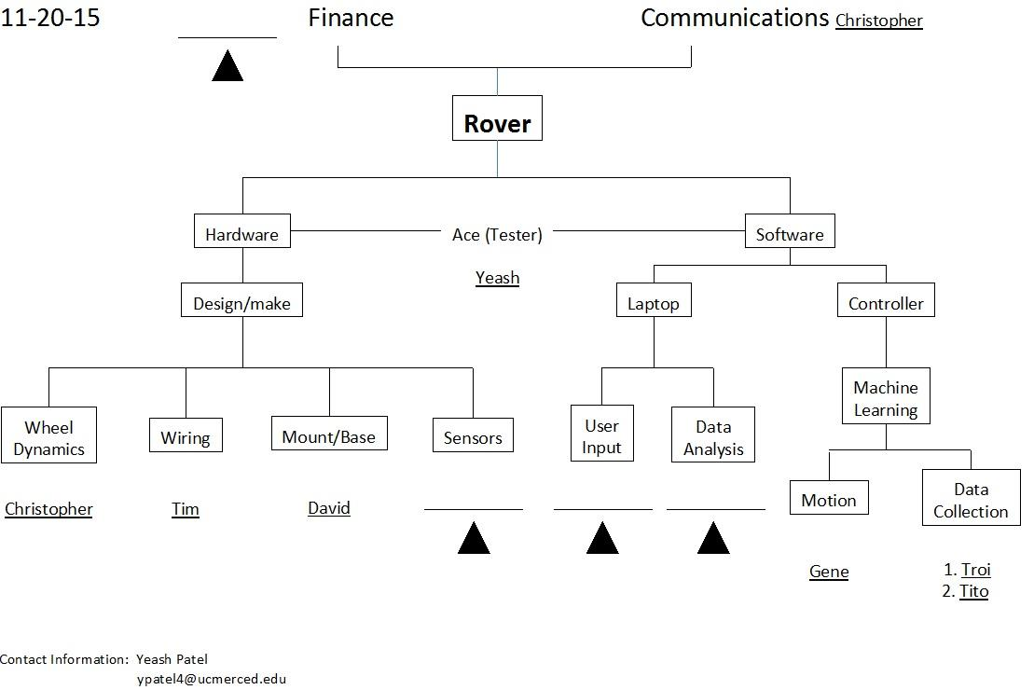

(As of 2015)

**Current Phase of Project and Location on Overall Project Timeline**

Goals for the Semester

Identify the specific goals for the project for the current semester, as agreed upon by the team,

**Semester Timeline**

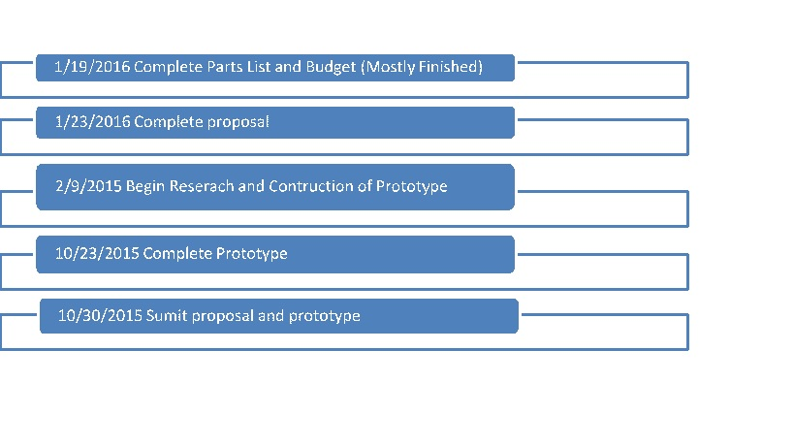

(Created by Christopher Lopez)

**Task Description**

The Merced rover group task is to create a **rover** that will be able to create a 3-D map of the environment that it is in and be able to navigate its way around the environment. This task is broken into a few parts. The first task is to create a prototype that will be able to navigate its way through a environment and be able to not hit an object that is in front of it this prototype will be gathering information on the objects that is in front of it and sending it back to the computer where it will be stored. The second task of the project is to create a larger robot than the prototype with more features than the prototype and be able to send back data to be used and viewed by either humans or other devices (e.g. a rover equipped for a more specific purpose).

One of the challenges that this task presents is having the robot sketch its environment and send the data back to the computer. A second challenge that is associated with our task is making sure that the external design of the rover does not hinder the movement or the task of the rover.

**Contact:**

For any inquiries please contact Yeash Patel at [ypatel4@ucmerced.edu](mailto:ypatel4@ucmerced.edu)